Getting study drugs into a patient's hands in 30 countries means 30 sets of import rules, label requirements, and approval lead times. Build the planner that knows each country's rules before the shipment gets stuck at customs.
Cleared for Takeoff - bsky13.docx

- Structure the rules. Build a searchable, sourced, dated country requirements model.
- Plan labels. Group countries into shared or separate label designs, with reasons.
- Ship-by dates. Turn lead times into a timeline of when to file, label, and ship, and flag countries at risk.
- Catch changes. When a rule changes, show which shipments, labels, and countries are affected.

Product ideas (AI agent)
Target: pharmaceutical companies in various countries
- Learned all present laws (updated)-> for labeling-> plan labels
- Notified when there is a law change-> more susceptible to be flagged-> catch changes
- Can predict transportation/logistics
- Create visual flowchart of every possible scenario -> ship-by dates
  - Ex. If there is geographical conflicts-> will take two weeks instead
- After approval of flowchart, implement into calendar

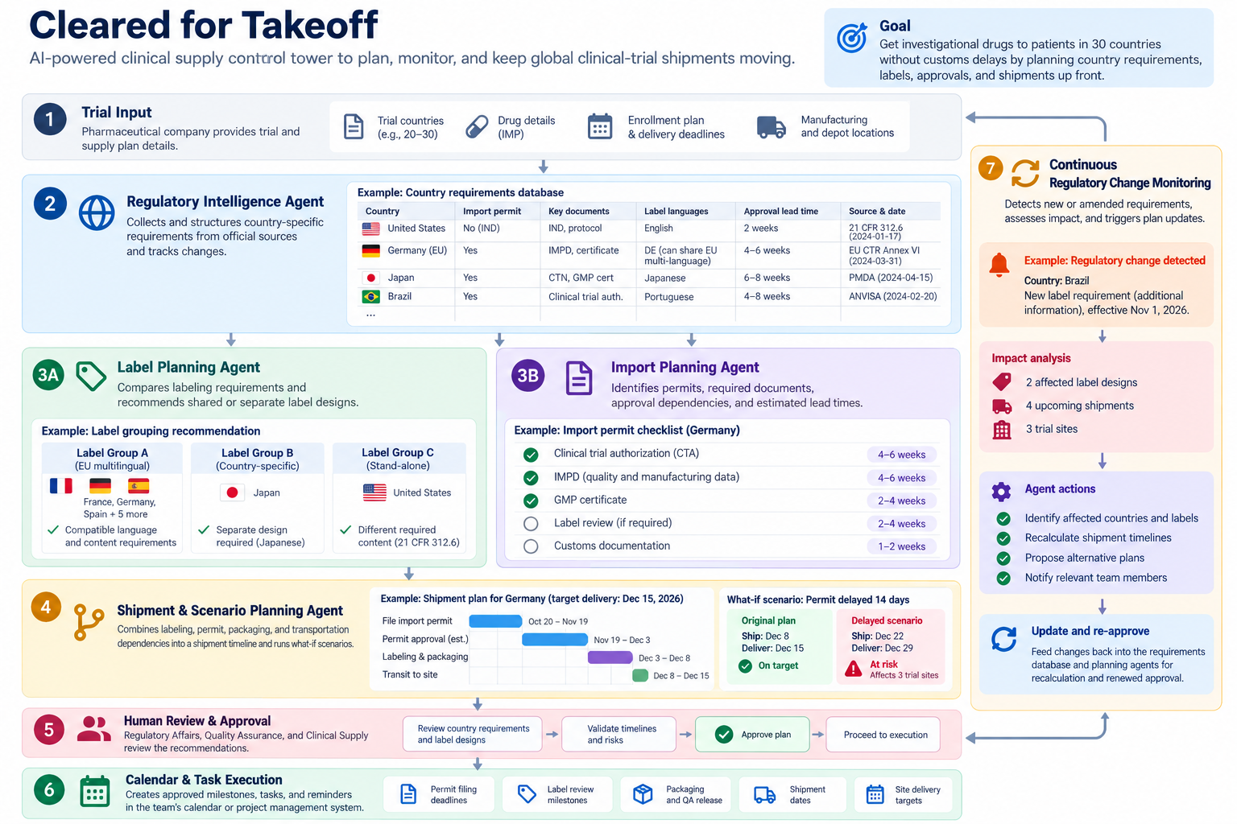

- One group chat= Collaborating with various industries
  - Logistics
  - Government
  - Research institutes
- Imessages feels more integrated in life (easier to check on a day to day basis)
  - → We should clarify the necessity of iMessage format for drug industrial sectors.
- Calling feature
  - Communicate complex ideas in their language
  - Photon translates
  - Communicates complex language
- How AI agent helps:
  - Provide up-to-date info regarding drugs, such as pandemic, air pollution, economic, war, importing/exporting rules, hygiene protocol, shipping/airplane situation, etc
    - + drug product info → Investigational medicinal product (IMP), Import permit, IMPD, Booklet label, Lead time, Depot, Customs hold
    - Most importantly, laws → AI models understand the different laws of different regions and they can suggest the optimal timeline based on that
  - Summarise the discussion of the group chat
  - develop the optimal cross-sector collaboration of different sectors based on that summary & the up-to-date info
    - Setting multiple parameters/tabs: Price, Amount, Which region to prioritize, which product to prioritize, timeline, etc
    - Make the optimal timeline for the whole logistics → Planner feature
  - Not only inside the same country but also international collaboration for the better and fair distribution of drugs all over the world → Communication beyond border → Language changes
- Language changes

CONNECT TO PHOTON VALUES:
- Vision: Does this push the frontier of hybrid intelligence?
- Craft: Is it cohesive, responsive, and tastefully integrated?
- Depth: How well does it handle real-world context and edge cases?
- Traction: Can we imagine this running with real users tomorrow?

Overall: (vision)
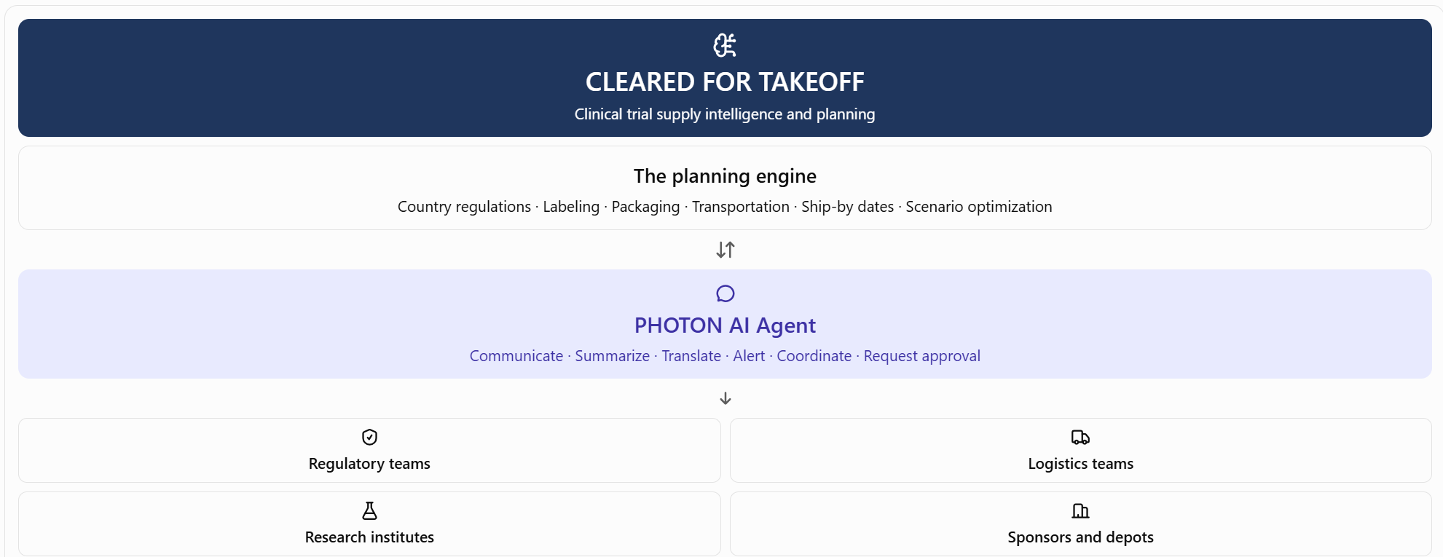
Smaller parts
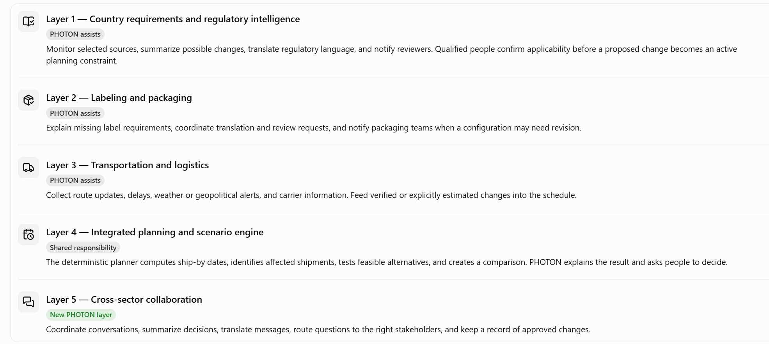
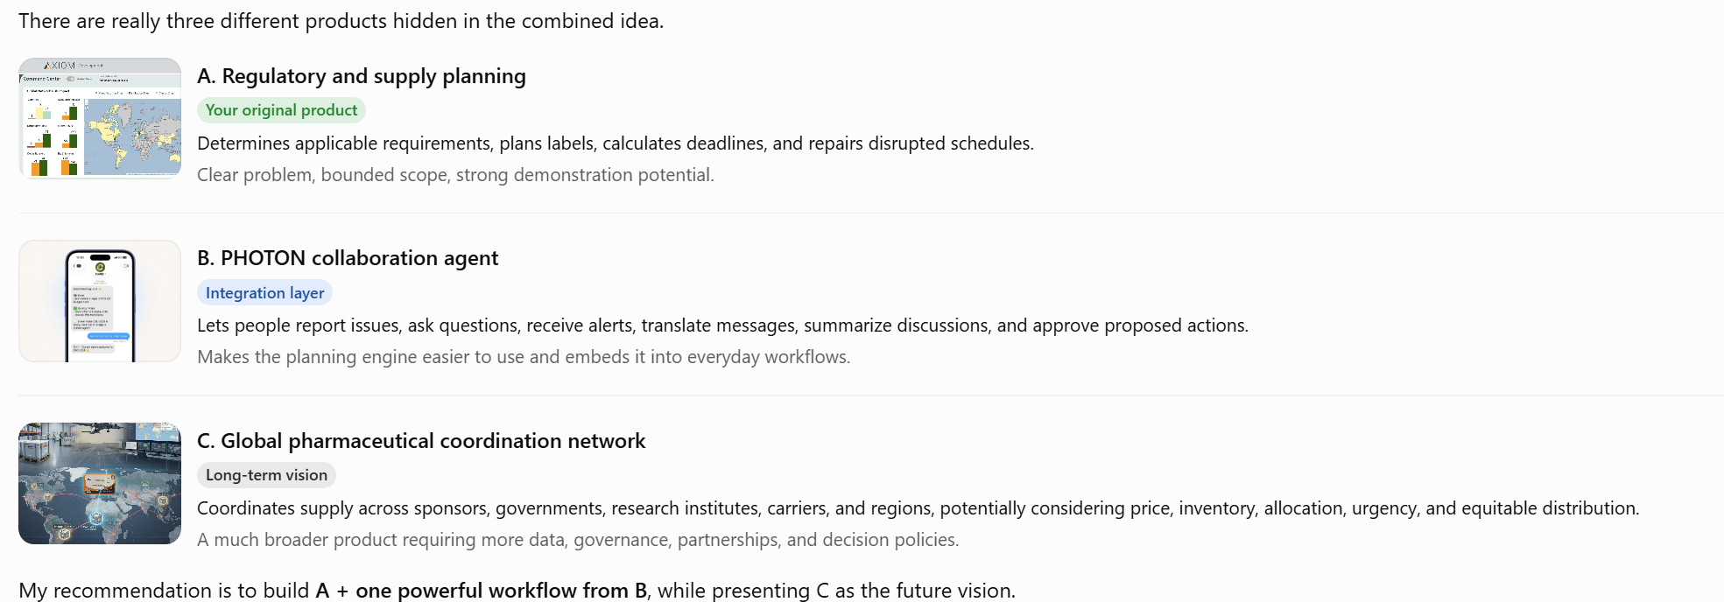
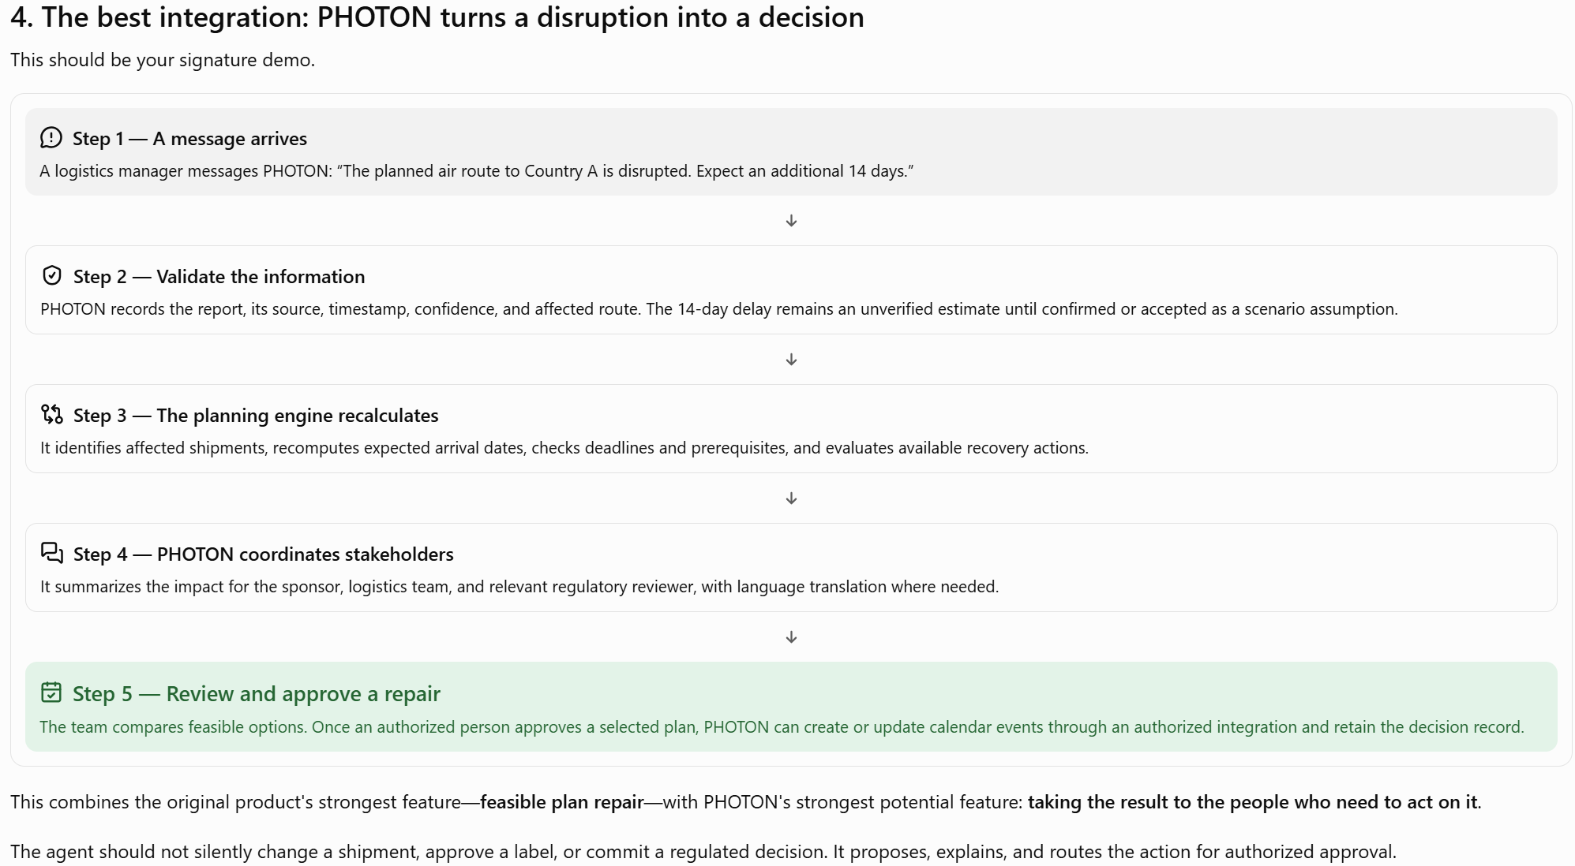

Planner: connect to google calendar? Or just make own timeline/calendar within that dashboard/website
The competition demo should have just four main screens:
- Control tower: Country coverage, shipments at risk, site deadlines, and current blockers.
- Requirements and timeline: Label, permit, packaging, transit, customs, and delivery dependencies.
- PHOTON conversation: A disruption arrives through messaging; the agent summarizes and routes it.
- Scenario comparison: Before/after timelines, affected shipments, feasible repairs, trade-offs, and approval.
That gives judges one coherent story instead of two competing products.
The strategic choice: keep CLEARED FOR TAKEOFF as the decision-making product, and make PHOTON its conversational coordination layer. Build the global collaboration network only after the team can prove that the core system correctly detects a disruption, recalculates the plan, and helps people choose a feasible response.

